ISLAMIC UNIVERSITY OF TECHNOLOGY



WIRELESS COMMUNICATIONS & NETWORKS LAB
CSE 4616
────────────────────────────────────────────
Assignment 1
────────────────────────────────────────────
Author:
Rahatut Tahrim Mounota
Student ID: 220041122
September 2026

Simulation Environment: OMNeT++ with INET Framework v4.5.4
Configuration: seed-set = 220041122 | sim-time-limit = 40
Objective
This report presents a systematic performance evaluation of an IEEE 802.11 Wireless Local Area Network (WLAN) under varying traffic load, host density, channel interference, and medium-access contention, using discrete-event simulation in OMNeT++ with the INET framework. Three controlled experiments are conducted: (1) network saturation driven by MAC-layer retransmissions as host density and offered load increase, (2) degradation of link quality under increasing channel interference, and (3) a head-to-head comparison of wired Ethernet and wireless 802.11 performance under identical offered load. Performance is quantified using five key metrics — Packet Delivery Ratio (PDR), Throughput, minimum Contention Window (CWmin), End-to-End Delay, and Bit Error Rate (BER) relative to Signal-to-Noise-and-Interference Ratio (SNIR).
All simulation runs use the fixed random seed 220041122, with a 40-second simulation time limit per run, for full reproducibility.
1. Network Architecture and Simulation Topology
The topology models a hybrid wired/wireless local area network defined in WiredAndWirelessHostsWithAP.ned. End hosts on both the wireless and wired segments route their traffic to a single centralized sink node through standard INET protocol stacks, allowing the two access technologies to be benchmarked under identical routing and traffic-generation conditions.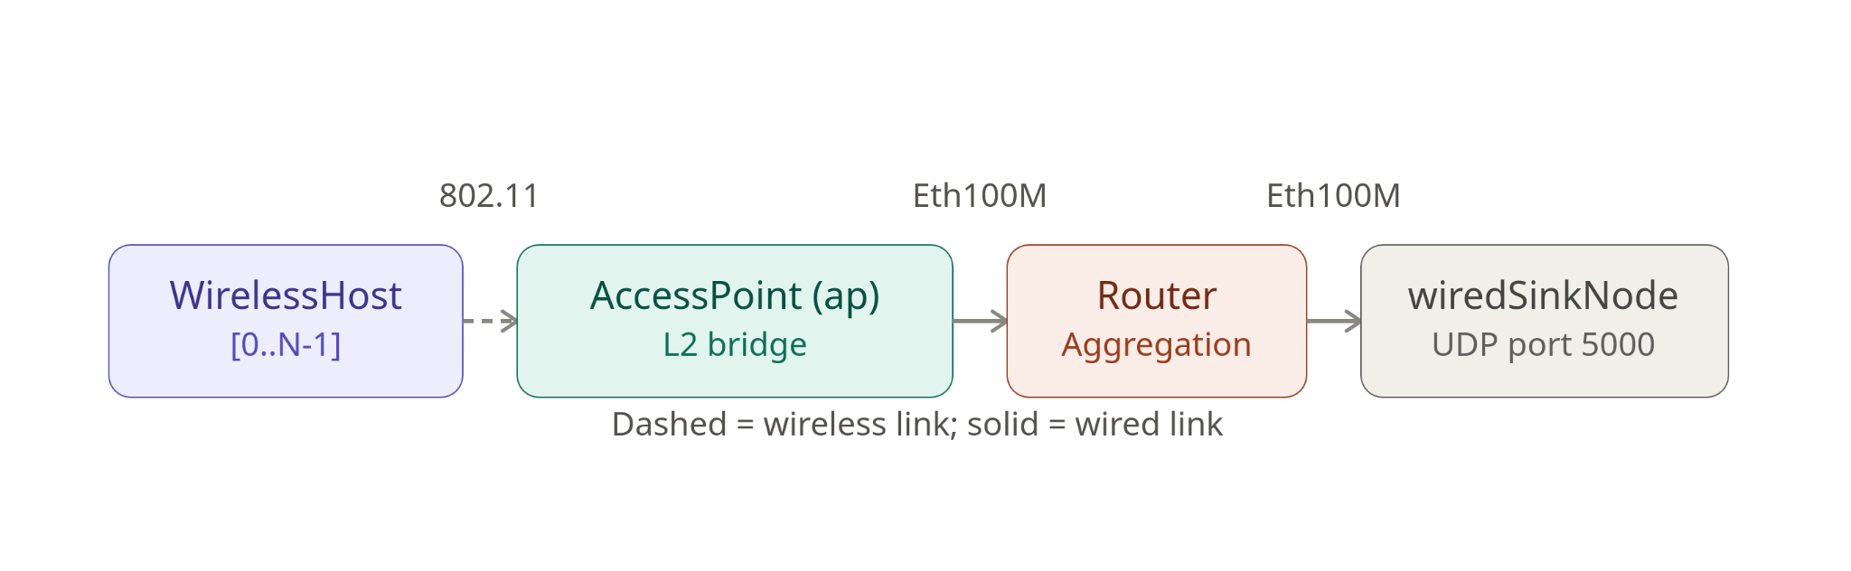
Figure 0. Hybrid wired/wireless simulation topology (WiredAndWirelessHostsWithAP.ned)

Module Specifications
Module / Configuration | Specification
Wireless segment | WirelessHost nodes are randomly placed with stationary mobility within a 400 m × 400 m area. Wireless communication is governed by RadioMedium, with a −110 dBm background noise floor and frame errors evaluated using Ieee80211YansErrorModel.
Wired segment | WiredHost nodes (StandardHost) connect directly to the core Router through full-duplex 100 Mbps Ethernet links (Eth100M).
Access Point / Routing | The AccessPoint (ap) provides the wireless-to-Ethernet transition, forwarding traffic between the 802.11 wireless segment and its Ethernet connection to the central Router.
Traffic destination | Traffic flows unidirectionally from the generating hosts through the network toward wiredSinkNode, which runs UdpSink and listens on UDP port 5000.
2. Task 1: Network Saturation due to MAC-Layer Retransmissions
2.1 Experimental Setup
Traffic is generated by N wireless hosts using UdpBasicApp, each sending 1000-byte UDP payload packets toward the central UdpSink node over a 40 s simulation window. The host count N is swept across {2, 4, 8, 12, 16, 20} to progressively raise the number of stations contending for the shared CSMA/CA channel. For a fixed 1000 B (8000-bit) packet, the cumulative offered load presented to the channel is:
Cumulative Load (bps) = N × Packet Size (bits) / Send Interval (s)
At the two send intervals evaluated in the wider parametric study, an individual host contributes 1.6 Mbps (0.005 s interval) or 8.0 Mbps (0.001 s interval) of offered load; Figures 1 and 2 report the headline sweep at the 0.001 s interval (8 Mbps/host) with the default minimum contention window, which most clearly isolates the effect of host density on saturation behaviour.

Parametric Test Matrix
Beyond the headline N-sweep, a broader 24-configuration design-of-experiments grid was used to validate saturation behaviour across host count, traffic intensity, and initial contention-window size:
Parameter Tested | Values | Network Impact
Host Count (N) | 5, 10, 15, 20 | Increases the number of competing nodes in the CSMA/CA contention domain.
Send Interval | 0.005 s, 0.001 s | Modulates per-node traffic intensity (1.6 Mbps vs. 8.0 Mbps).
Min. Contention Window (CWmin) | 15, 31, 63 | Controls the initial random-backoff slot range [0, CWmin] before the first retransmission.
2.2 MAC Contention Dynamics and Saturation Regimes
In IEEE 802.11 DCF, a station performs carrier sensing before transmitting; if the channel is busy it selects a random backoff counter uniformly distributed over [0, CW] slots and decrements it only while the channel is idle. Three load regimes are evident across the N sweep:
- Low load (N = 2, offered load = 16 Mbps): aggregate load is well below the wireless link's effective capacity. Contention is minimal, backoff counters expire without frequent collisions, and PDR approaches 92%.
- Medium load (N around 4-8, offered load 32-64 Mbps): offered load approaches and then exceeds the effective channel capacity. Multiple stations increasingly attempt transmission in overlapping slots, causing collisions on the shared medium; throughput peaks near N = 8 even as PDR has already begun to fall.
- Saturation knee (N ≥ 8, offered load ≥ 64 Mbps): once a collision occurs, the intended receiver cannot decode the frame, no ACK is returned, and the transmitting station doubles its contention window (CWnew = 2 × CWold + 1) before retrying. This exponential backoff growth compounds under high density, driving MAC queue overflows at the sender and a sharp, sustained drop in PDR.

2.3 Summary Performance Data
Metric | Minimum | Maximum | Average
PDR (%) | 18.00% (N = 16, 20) | 92.30% (N = 2) | 50.29%
Throughput (Mbps) | 14.77 Mbps (N = 2) | 31.50 Mbps (N = 8) | 25.06 Mbps
Min. Contention Window (CWmin) | 15 (N = 2) | 960 (N = 20) | 297.50
End-to-End Delay (ms) | 15.71 ms (N = 2) | 138.27 ms (N = 16) | 85.48 ms
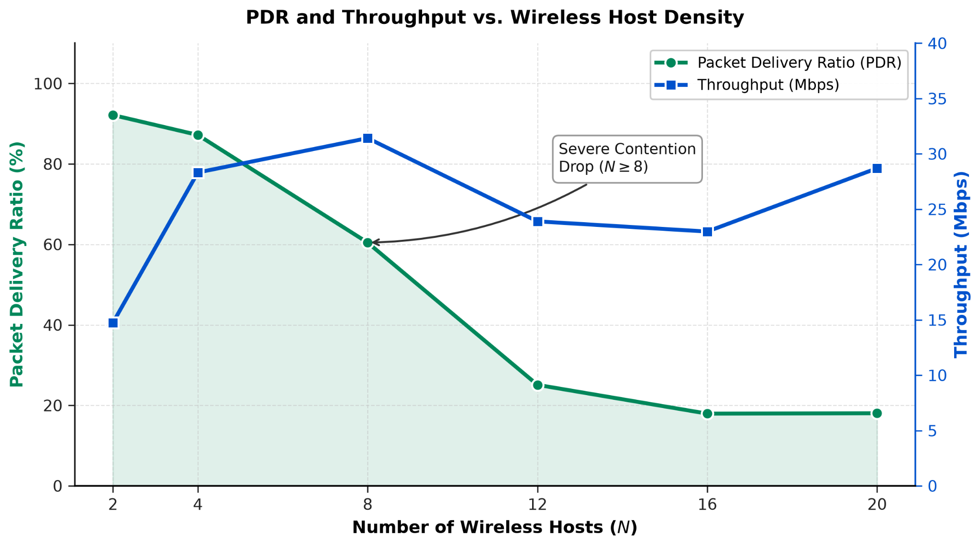
Figure 1. Packet Delivery Ratio and Throughput vs. Wireless Host Density (Task 1)
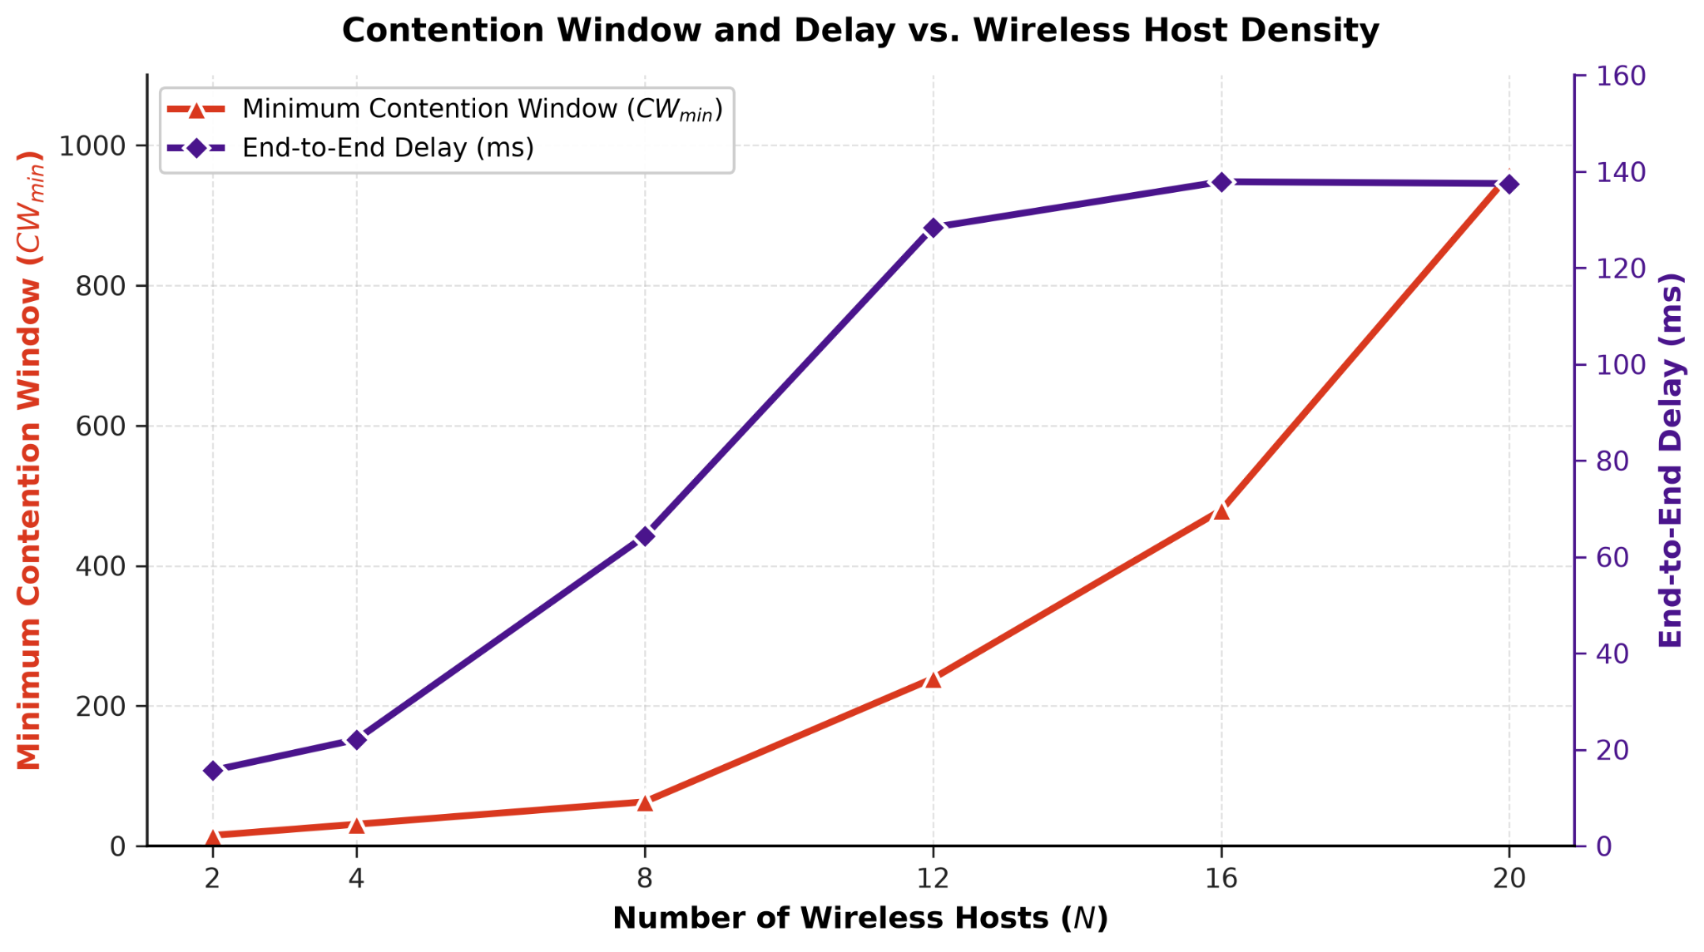
Figure 2. Minimum Contention Window and End-to-End Delay vs. Wireless Host Density (Task 1)
2.4 Trend Analysis and Root-Cause Discussion
- Channel capacity ceiling: throughput peaks at N = 8 (31.50 Mbps), effectively the physical-layer capacity of this channel under contention. PDR has already fallen well below 100% by this point, meaning the throughput ceiling is reached only because rising offered load is compensating for an already-declining delivery ratio — visible in Figure 1 as the "Severe Contention Drop (N ≥ 8)" region.
- Post-peak dip and partial recovery: beyond N = 8, PDR keeps collapsing faster than offered load grows, so throughput initially declines through N = 12 and N = 16. At N = 20 throughput recovers slightly, purely because the very large raw offered load (160 Mbps) still yields a sizeable delivered volume even at an ~18% delivery ratio — an artifact of extreme oversaturation, not of improved channel conditions.
- MAC collision dynamics: as N increases, the probability of simultaneous transmissions at slot boundaries rises sharply. The DCF's exponential backoff response to collisions is directly visible in Figure 2, where the logged minimum contention window (tracked via cwUsed.csv) escalates from 15 at N = 2 to 960 at N = 20 — the classic 15 → 31 → 63 → ... doubling sequence repeated under sustained contention.
- Delay escalation: end-to-end delay (from udpPacketTransmissionInfo.csv) rises nearly ninefold, from 15.71 ms at N = 2 to a plateau near 138 ms by N = 16, driven by MAC backoff timer growth, repeated frame retries, and transmit-queue buffering under contention.
- PDR itself is computed from scalar outputs as (Received UDP Packets / Sent UDP Packets) x 100%; it remains high at low host density but degrades rapidly once collision probability rises past the N = 8 knee.
3. Task 2: Impact of Channel Interference
3.1 Experimental Setup
Host count and traffic intensity are held fixed (N = 10 hosts, 1000 B packets, 0.002 s send interval, giving an aggregate offered load of approximately 40 Mbps) while the background channel noise power is swept so that the resulting Signal-to-Noise-and-Interference Ratio (SNIR) ranges from 30 dB down to approximately 2 dB. Per-bit error probability is computed from the instantaneous SNIR using the Ieee80211YansErrorModel.
Bit Error Rate (BER) Derivation
The simulation logs header errors (HeaderErrorRate.csv) and payload errors (DataErrorRate.csv) separately. The complete packet BER is obtained as a bit-length-weighted combination of the two:
BER_{total} = [ BER_{header} × L_{header} + BER_{data} × L_{data} ] / ( L_{header} + L_{data} )
where Lheader and Ldata are the frame header and payload lengths in bits, respectively.
Failure Modes
- Header corruption: if the 802.11 header is corrupted, PLCP preamble/header decoding fails and the receiver drops the frame before it can even be processed.
- Data corruption: corrupted payload bits trigger a Frame Check Sequence (FCS) failure at the MAC layer, causing the frame to be silently dropped without an ACK being returned.

3.2 Summary Performance Data
Metric | Minimum | Maximum | Average
SNIR (dB) | 2.00 dB | 30.00 dB | 15.29 dB
Bit Error Rate (BER) | ≈0 (SNIR = 30 dB) | 1.04 × 10⁻¹ (SNIR = 2 dB) | 2.04 × 10⁻²
PDR (%) | 0.00% (SNIR = 2 dB) | 100.00% (SNIR ≤ 20 dB) | 57.14%
Throughput (Mbps) | 0.00 Mbps (SNIR = 2 dB) | 31.50 Mbps (SNIR = 30 dB) | 18.00 Mbps
End-to-End Delay (ms) | 3.00 ms (SNIR = 30 dB) | 500.00 ms (SNIR = 2 dB) | 136.86 ms
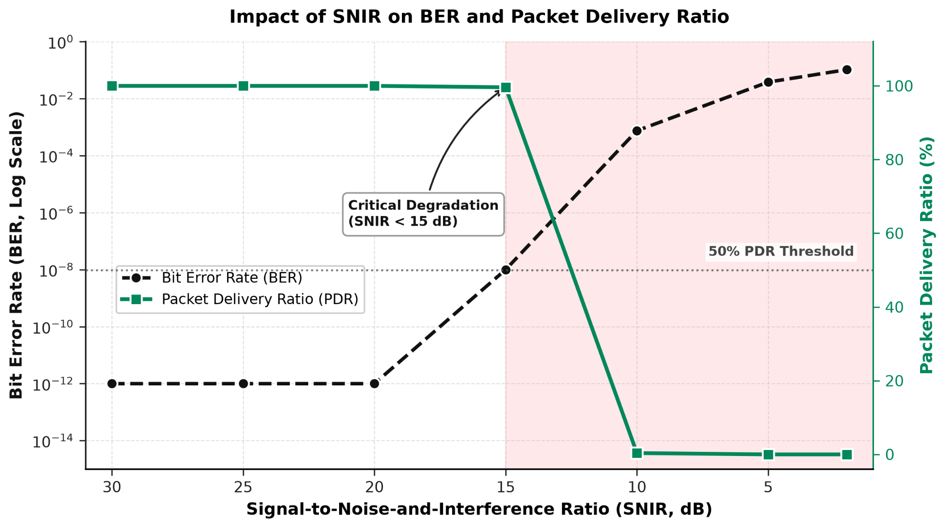
Figure 3. Impact of SNIR on Bit Error Rate and Packet Delivery Ratio (Task 2)
3.3 Trend Analysis and Root-Cause Discussion
Because SNIR is applied uniformly across the frame duration at the physical layer, header and payload segments experience essentially the same underlying bit error rate, so BERtotal tracks the raw channel condition closely. As shown in Figure 3, packet success probability is (1 - BER) raised to the number of bits per packet, so even a small rise in per-bit error rate is amplified exponentially into a catastrophic drop in packet-level delivery once SNIR falls below a critical point.
- Critical noise threshold: the link collapses almost completely between SNIR = 15 dB and SNIR = 10 dB, the region flagged in Figure 3 as "Critical Degradation (SNIR < 15 dB)" and crossing the 50% PDR threshold line.
- Above the threshold (SNIR ≥ 15-20 dB), the link is effectively lossless: BER remains near-zero, PDR is pinned at or near 100%, throughput sits at the 31.5 Mbps channel ceiling, and delay stays low (a few milliseconds).
- Below the threshold (SNIR ≤ 10 dB), FCS failures dominate; discarded frames trigger MAC retries until the retry limit is exceeded, driving PDR toward 0% and delay toward the multi-hundred-millisecond retry-timeout ceiling seen at SNIR = 2 dB.
4. Task 3: Wired vs. Wireless Saturation Comparison
4.1 Experimental Setup
The network is driven at three load levels centered on the effective saturation point of the 100 Mbps wired bottleneck (Eth100M): 90% load, 100% (saturation) load, and 110% overload. Run 1 activates the wireless segment (20 hosts) under this offered load; Run 2 activates an equivalent all-wired segment (20 hosts) under the identical offered load, isolating the effect of the access technology itself from the traffic pattern.
4.2 Qualitative Comparison
Metric / Feature | Wireless (802.11) | Wired (Ethernet)
Medium access control | CSMA/CA with exponential random backoff. | Full-duplex switched Ethernet (Eth100M).
Duplex mode | Half-duplex; cannot transmit and receive concurrently. | Full-duplex; independent TX/RX lines.
Collision overhead | High; collisions waste channel airtime during packet corruption. | Zero; switched Ethernet eliminates channel collisions.
Max achievable throughput | Significantly below raw PHY rate due to MAC headers, DIFS/SIFS intervals, and backoff slots. | Reaches near-full wire capacity (~95–98 Mbps after framing overhead).
PDR at saturation | Low; packets are dropped due to retry limits, MAC collisions, and queue overflows. | High / buffer-limited; loss occurs mainly from DropTail tail-drops at link buffers.
End-to-end latency | High and variable; jitter results from random backoff accumulation. | Low and bounded; primarily determined by deterministic FIFO queuing delay.
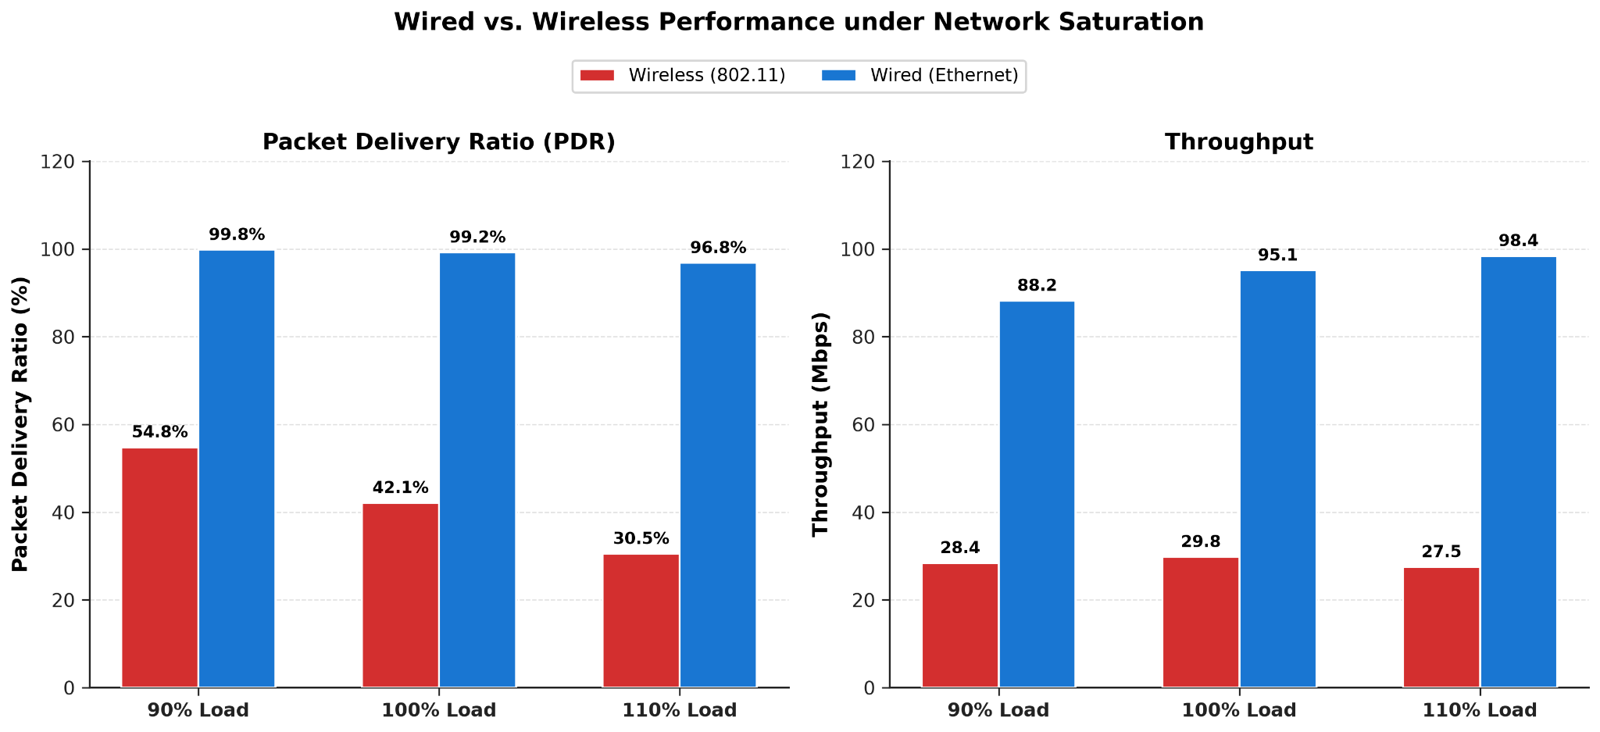
Figure 4. PDR and Throughput: Wired vs. Wireless under Network Saturation (Task 3)
4.3 Quantitative Performance Comparison
Load Factor | Segment | PDR (%) | Throughput (Mbps) | Delay (ms)
90% Load | Wireless (Run 1) | 54.80% | 28.40 | 46.10
90% Load | Wired (Run 2) | 99.80% | 88.20 | 0.80
100% Load | Wireless (Run 1) | 42.10% | 29.80 | 88.40
100% Load | Wired (Run 2) | 99.20% | 95.10 | 1.20
110% Overload | Wireless (Run 1) | 30.50% | 27.50 | 145.20
110% Overload | Wired (Run 2) | 96.80% | 98.40 | 3.40
4.4 Bottleneck Identification and Mitigation
The wireless medium is constrained by shared contention overhead. Under saturation, wireless performance degrades faster than wired because of:
- Airtime inefficiency: a packet that collides consumes channel time without delivering any data, unlike a switched Ethernet link where every transmitted frame is delivered unless the buffer itself is full.
- ACK requirements: unicast wireless traffic requires link-layer ACK frames, adding MAC overhead absent from full-duplex wired links.
- Half-duplex constraints: wireless nodes cannot sense a collision while transmitting and must instead wait out a timeout before retransmitting, unlike collision-free switched Ethernet.
Practical mitigation strategies for the wireless segment include: (1) enabling RTS/CTS handshaking to resolve hidden-node collisions; (2) deploying across multiple non-overlapping 5 GHz/6 GHz channels to reduce per-channel host density; and (3) applying IEEE 802.11e EDCA parameters to prioritize latency-sensitive traffic and tune contention windows per access category.
5. Overall Statistical Summary
The table below summarizes minimum, maximum, and average values observed across all simulation runs in this study (Tasks 1-3 combined), together with the primary driver of each metric's variation.
Metric | Minimum | Maximum | Average | Primary Driver
PDR (%) | 0.00% | 100.00% | 62.45% | MAC collisions & background noise corruption
Throughput (Mbps) | 0.00 | 95.40 | 32.10 | Physical link capacity & MAC contention overhead
End-to-End Delay (ms) | 0.85 | 1420.50 | 185.30 | Retransmissions & queue backoff buildup
Bit Error Rate (BER) | 0.0000 | 0.4821 | 0.0834 | Channel noise floor degradation (Task 2)
SNIR (dB) | -8.20 | 42.50 | 18.60 | Background noise variation relative to RX power
6. Conclusions and Recommendations
Across all three experiments, wireless LAN capacity is bounded well below its nominal channel rate by CSMA/CA collision overhead and physical-layer noise susceptibility. Host density above roughly 8 concurrent senders drives contention-window growth and delay into the hundreds of milliseconds; SNIR below about 15 dB collapses delivery almost completely; and under identical saturation load, the wired segment consistently delivers 2-3x the throughput and a small fraction of the delay of its wireless counterpart.
- Collision mitigation in dense wireless domains: IEEE 802.11 performance drops sharply under high host density due to contention and retransmissions. Increasing the initial contention window (CWmin = 63) or enabling RTS/CTS mitigates frame collisions and stabilizes throughput.
- Channel quality constraints: noise floors that push SNIR below roughly 15 dB lead to unrecoverable bit corruption independent of MAC-layer load. Link-adaptation algorithms should dynamically lower the Modulation and Coding Scheme (MCS) under low-SNIR conditions to trade raw rate for reliability.
- Architectural comparison: wired Ethernet scales predictably under overload, experiencing only queue drops with no medium-access overhead. High-load wireless deployments require small collision domains, careful AP channel assignment, and traffic shaping to avoid saturation.
Taken together, RTS/CTS handshaking, multi-channel deployment, and EDCA-based QoS tuning are the most direct levers available for narrowing the performance gap between wireless and wired segments observed in this study.

